DAOCAT 😺

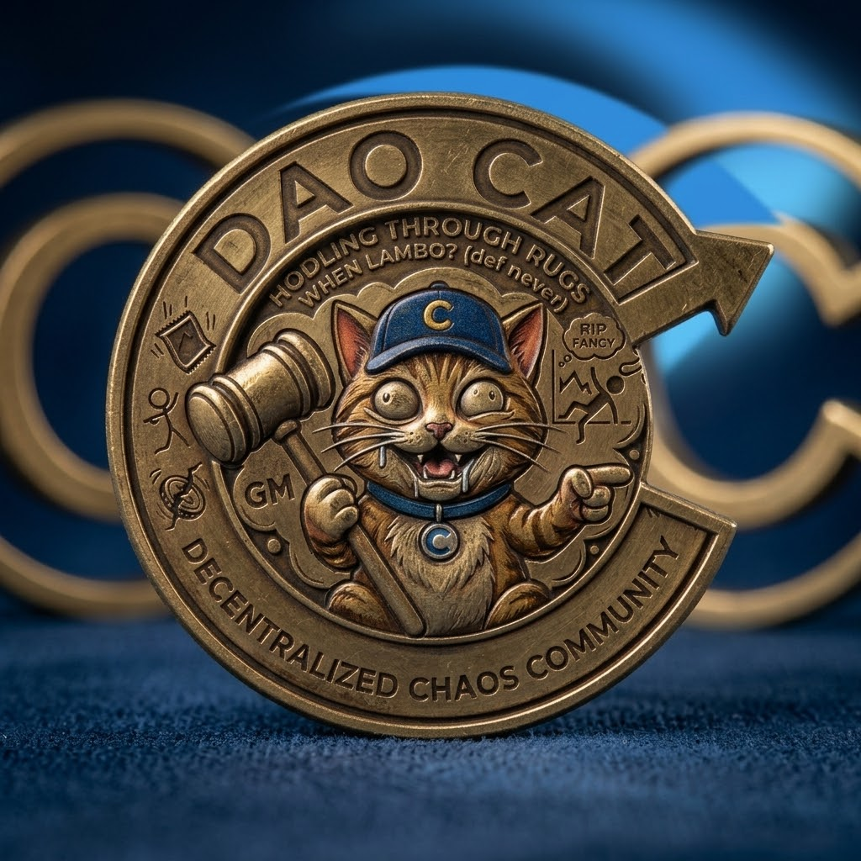

- $DAOCAT WHITE PAPER

This is the token we made for the people still learning crypto and for the Carib DAO folks who already know how wild this space gets.

It’s called DAOCAT. It’s a meme, but the point was always to have something real that new people could actually buy, hold, and mess around with so they could see how things work instead of just reading about them. No big promises. No presale. Just the coin.
It launched in October 2026 on Sui through Perpsplexity.

- What we wrote when we
launched it

🐾 DAO cat ($DAOCAT) 😺

The ultimate fan-made meme token of @CaribDAO! 🌊 🌴

The Decentralized Chaos Community! 🐱
We aren't here to promise you a Lambo
(def never).

We are here to build a community that HODLs through the absolute madness of the crypto markets.

💎 The Vibe: Pure, unfiltered decentralized chaos.

🔨 The Weapon: The Ban-Hammer for the jeets.

🤝 The Promise: We survive the rugs together.

Grab your $DAOCAT, hold on tight, and let’s make some noise! Meow. 🐾🔥

- Why we made it

Most memes are just trying to pump. We wanted something people could use to learn. How buying works. How fees come back to holders. How a launch actually plays out. How you trade the same token in different places. And how a community like Carib DAO tries to stick together when things get messy.

Carib DAO has always been about teaching crypto in a real way. This is just one small piece of that.

- The simple facts
- Sui chain
- Launched on Perpsplexity
- No presale
- 1 billion total supply, fixed
- No team tokens sitting aside

Contract:

0xe7711ddd0f61e6eb0811e2e325fbdcd6d6a6f2d6d956207387792942a8eea0fa::daocat::DAOCAT

- What was made is what’s out there

- How the launch worked

It started as a normal spot pair with a $5,000 starting market cap.
At first there’s some virtual liquidity so the early price isn’t stupid.

While people are still buying in, the real money sits in cash. Once $5,000 of actual money is in the pool, it can be bonded.

When that happens the virtual liquidity goes away, half the leftover supply gets burned, and the price stays the same. After that it’s fully live.

You can see all of it on-chain. No one has to trust a story.

- Buying and holding

You buy it on Perpsplexity. Trades pay a fee and part of that fee goes back to the people who are holding. You claim it when you want.

There’s also an exit fee that starts at 5% if you sell right away and slowly drops down toward 0.5% over about 30 hours. Fast flips cost more. The fee still ends up helping holders either way.

You can also trade it on Cetus (SUI/DAOCAT) and on Aftermath (CARIB/DAOCAT and SUI/DAOCAT).

Those are separate pools. People can use them whenever they want.

- What it’s for

It’s a meme for Carib DAO. Something people can talk about when they’re explaining holding, fees, or just not folding every time the market gets crazy.

It’s not a governance token for the DAO.
It’s not a roadmap. It’s just a shared token that fits the “decentralized chaos” feeling and gives newcomers something real to practice with.

- What we’re not saying
- We’re not promising a Lambo.

- We’re not saying the price goes up
- We’re not saying the fees will be big.

- We’re not saying this makes anyone rich.

Volume makes the fees. Markets do what they do. Liquidity can be thin. That’s normal.

The only thing we said from the start is that we try to hold through the madness and survive the rugs together.

- DAOCAT is an edu-meme.

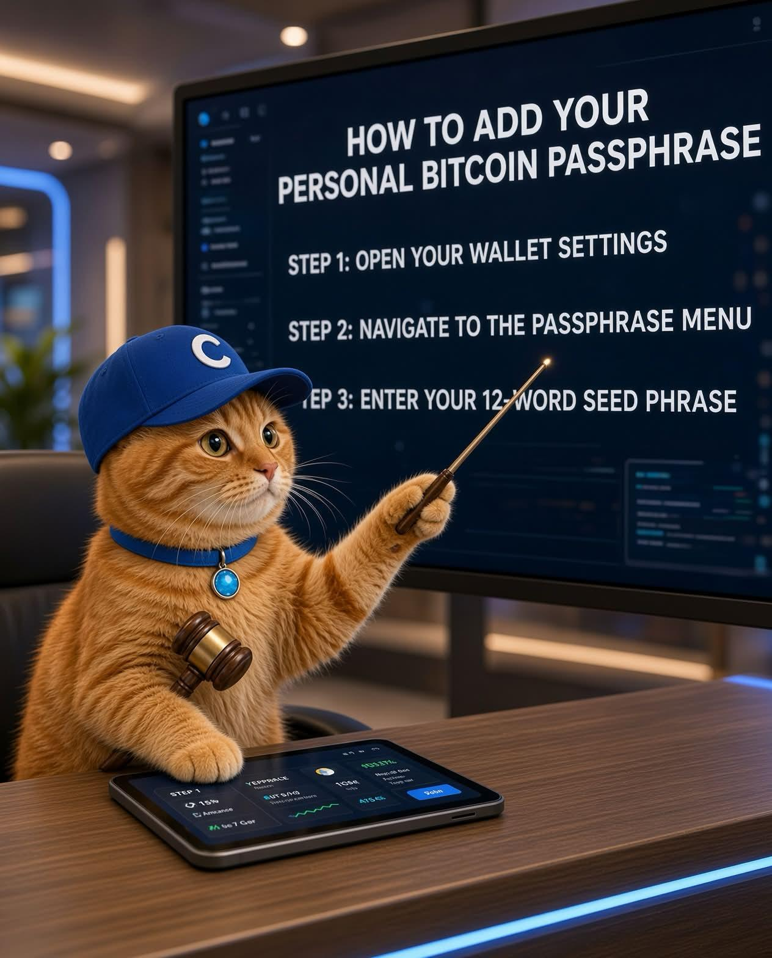

The useful part is what people pick up by actually using it and talking about it, not any chart prediction.

Buy some if you want to be part of the Carib DAO space and see how the mechanics work with your own wallet.

Hold if you want to stick around. That’s the whole thing.
This is just information.

- Disclaimer

It’s a speculative meme token. You can lose everything you put in. Do your own research and only use money you can actually afford to lose.

Meow 🐈. Hold through the chaos. Learn something.

